Componant Diagram for RPSRrec (Android) program
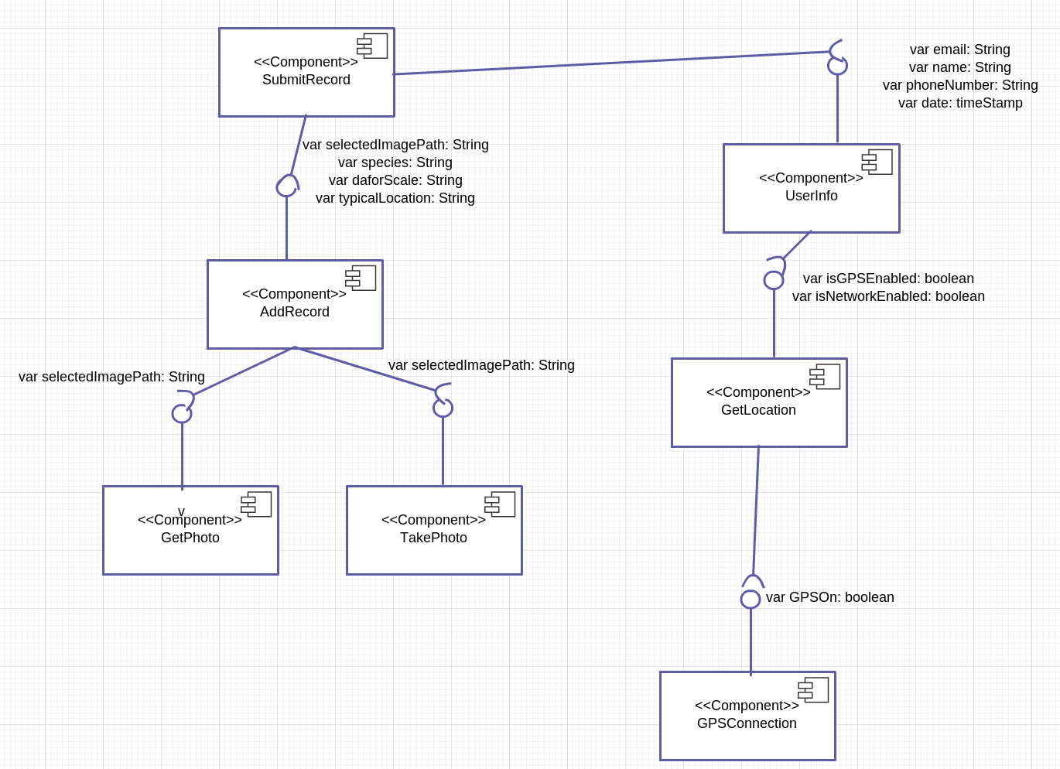
Group 3
TOP KEK | Llandinum Bldg, Penglais, Aberystwyth, Dyfed SY23 3DB,
©Group 3, Aberystwyth University

